The Club’s effluent system must be inspected, maintained and plans and procedures kept on site at the Club. This template may help your Club track and understand the requirements.

The Club should maintain records and there are some items that must be submitted with the Annual Club Audit.
The shaded boxes show what a qualified plumber needs to inspect annually and list on their Effluent Systems Compliance Report. The plumber’s Report is Activity 8 of the Annual Club Audit Requirements and should be submitted to GMW as part of the Annual Club Audit.
Some items must be completed by a qualified plumber however there are others that may be completed by the Club, the responsible person is listed below.
Club Name: Year of Club Audit: ………………………………………………………………………

Item | Requirements of work to be completed | Frequency | Responsible Party or Person | (Include the date and person or business who completed the work)
 |  |  |  | Jan | Feb | Mar | Apr | May | Jun | Jul | Aug | Sep | Oct | Nov | Dec
Club effluent system plans | The Club must hold detailed drawings of the effluent system including:  - layout and location of amenity blocks  - septic tank locations and capacities  - wet wells, and  - drainage pipework on the club lease.  (Refer to the example Plan on page 4).  These Plans must be kept on site at the Club (do not submit your Plan with the Annual Club Audit). | Review the Plans annually | The Club
Effluent Emergency Response Procedure (Audit requirement activity #9) | An Effluent Emergency Response Procedure must be in place. For details and information on what needs to be submitted with your Annual Club Audit refer to the Annual Audit Club Audit Requirement document, Activity 9 – Effluent Emergency  Response Procedure. | Update and submit the Procedure to GMW annually | The Club
 | The Procedure should be displayed as a sign adjacent the wet well high level visual alarm. Check this sign is visible every month. | Check signage is in place monthly | The Club
Amenity blocks | Confirm cisterns/taps/shower roses do not leak.  List individual amenity blocks to ensure all are checked. | Check amenity blocks monthly | The Club
Septic tanks | Septic Tank Clearance – For details on what needs to be submitted to GMW, refer to the Annual Audit Club Audit Requirement document, Activity 7 - Septic Tank and Transfer Pit (Effluent) Clearance. | Annually – with Club Audit | Qualified Plumber or Contractor
Septic tanks | Visual inspection of area surrounding the septic tanks for signs of leakage. Signs may include excess greenery (vegetation growth) or soft patches of soil at the grounds surface. | 3 monthly | The Club
Wet wells (refer to information on page 3) | Confirm if a submersible pump is installed and operating. | Monthly | The Club
Wet wells (refer to information on page 3) | Confirm wet well operation - complete pump down test. This should also be timed to confirm correct operation of the pump. | Annually – with Club Audit | Qualified Plumber
Wet wells (refer to information on page 3) | Trip high level alarm - confirm operation of flashing high level warning light and audible alarm. | 6 monthly – with Club Audit | Plumber annually  Club 6 monthly (mid year)
Wet wells (refer to information on page 3) | Confirm minimum 200 litres of air space (above high level alarm trigger point and below top of well). | Annually – With Club Audit | Qualified Plumber
Wet wells (refer to information on page 3) | Check electrics and controls are safe and compliant. | Annually – With Club Audit | Qualified Plumber
Wet wells (refer to information on page 3) | Check covers are child proof and tamper proof. | Annually | The Club
Effluent lines - wet well to club boundary | Visual inspection of area surrounding the septic tanks for signs of leakage. Signs may include excess greenery (vegetation growth) or soft patches of soil at the ground’s surface. | 3 Monthly | The Club
Maintenance record | Records maintained of all inspections and works kept on site at the Club. Records should include details on the work undertaken and date completed. | As completed | The Club

Example – Wet Well
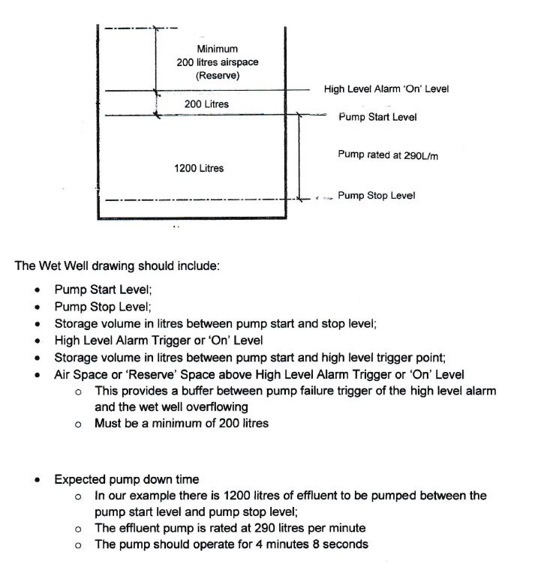

Example – Club Effluent System Plan
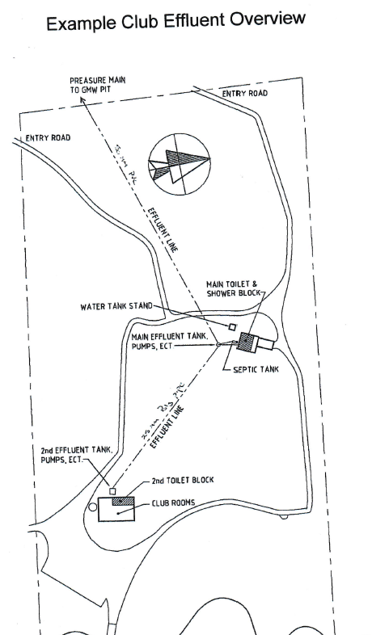
Example Legend
Effluent line
Toilet/shower block
Road

Details to include on your plan:
- Label structures
- Label size of pipes

